***Which is the best educational platform out of all- udemy, Coursera etc.***

***Share your views over all these platforms with differences and similarities***

**E-learning was introduced to the world as some of the brightest talents were unable to acquire required skills which they deserved and were not provided the access to classrooms due to various reasons and therefore E-learning has emerged as a very big market for companies like Udemy, Coursera, Unacademy to expand their existence.**

**An Educational Platform can be judged by what it provides and in what price it provides which is generally a deciding factor which the customer chooses from and then heads on to a particular platform.**

**The main difference between Udemy and Coursera is, Udemy provides courses from independent authors whereas Coursera provides accredited courses designed by top universities and multinational corporations. Udemy charges for each course, which can go as low as $10 while Coursera’s pricing is kind of complex. Both have their pros and cons.**

**There are two big advantages of Udemy:**

1. **Its courses are usually available at a very small price. It keeps of running promotional offers throughout the year, You can often buy it courses for as low as $10.**
2. **It gives lifetime access to all its courses.**

**Disadvantages -**

1. **It has no standardization of its courses as they are developed by independent instructors who are not employed by Udemy. Each course has a different teaching style and some of them may not even have good quality. So, you have to be careful before buying a course.**
2. **Udemy does have any quality control process for approving the content of a course. The instructors almost get a free hand to make and publish their courses. Due to this reason, there is a vast difference between the quality of published courses – you can find very good as well as very bad courses.**

**Coursera differs from Udemy in the sense that it provides only college-style learning to its users. They have tied-up with some of the best universities in the world and provide their courses in the online mode.**

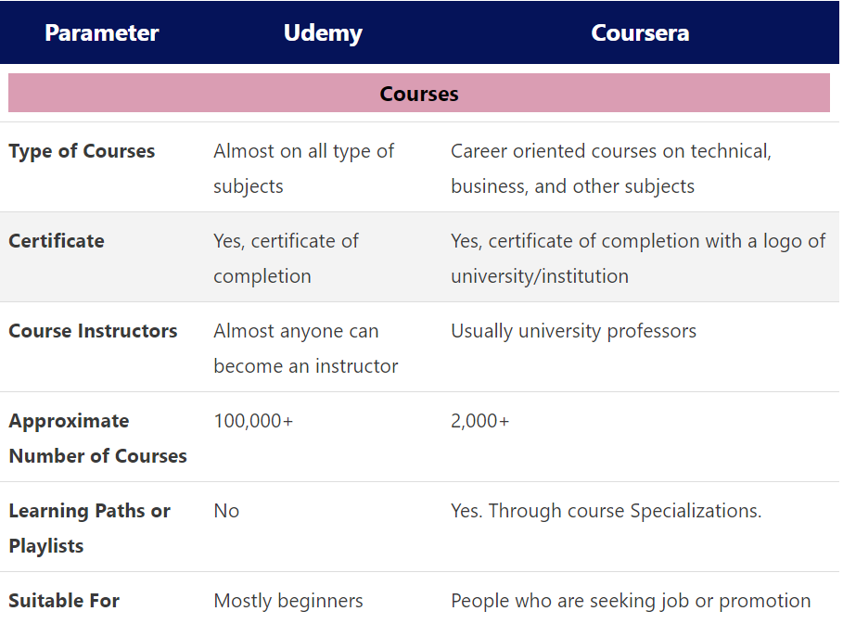

**The choice remains to what a person is looking for if the requirement is a certificate then Coursera is the way to go.**